Exploring how climate will impact plant-insect distributions
and interactions using open data and informatics

- Mac and PC Instructions for Downloading R -
To download R
- Go to www.r-project.org
- On the left hand side of the screen under the Download header, click on CRAN (this stands for Comprehensive R Archive Network)
- This brings up a number of mirrors from which you can download R. Scroll down to ‘USA’ and click the first link associated with University of California, Berkeley, CA
- In the top box labeled ‘Download and Install R’ choose the link that matches your operating system (likely either ‘Download R for (Mac) OS X’ or ‘Download R for Windows.’ This may take a few minutes.
- Follow the instructions for either Mac or PC below

Continuing the download of R for a Mac
- Once you click on ‘Download R for (Mac) OS X’ you will be brought to a screen that looks like the figure below. Download the latest version of R by clicking the first R-X.Y.Z.pkg link in the list (“X.Y.Z” will be replaced with the version number. The image below shows the process for R version 3.4.2.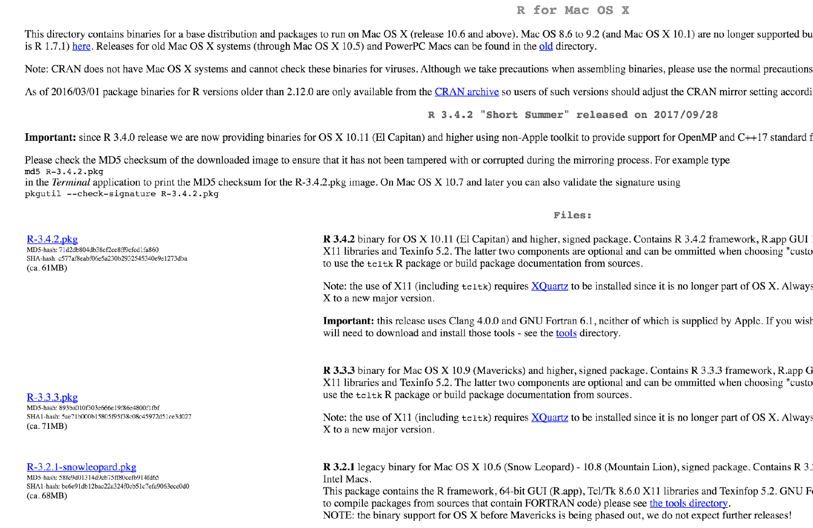

- Once downloaded, double click on the R installer in your downloads folder.
- A pop up wizard will appear to walk you through installation. Follow the instructions to install.
- You should now see R in your applications folder.

Continuing the download of R for a PC
- Once you click on ‘Download R for Windows’ a new window will appear. Click on ‘base’ under subdirectories.
- In the next window, click on ‘Download R X.Y.Z for Windows’ in the grey box at the top of the screen (where “X.Y.Z” will be replaced by the version number, e.g. “3.4.2”). If it asks you to save the file rather than automatically download the file, save the file.
- Click on the file you just downloaded (e.g. R-3.4.2-win.exe) to execute it. When the dialog box opens, click RUN.
- A setup wizard should appear. Follow the prompts of the wizard to install R using all of the defaults.

Troubleshooting
- If you are using a Mac: https://youtu.be/cmj8Oi6PFe0
- If you are using a PC: https://youtu.be/9-RrkJQQYqY

